SAMPLE SPECIFICATION for DRILLED SHAFT BASE CLEANLINESS using SQUID

In using this sample specification, it should be recognized that each site and structure is unique. Therefore, geotechnical judgment based upon knowledge of the local soil conditions and deep foundation installation practice should be used to modify this sample specification to address the requirements of a specific project.

SECTION 1.0 – GENERAL

1.01 Summary of Work

The (Engineer, Specialty Testing Consultant, Quality Control Agency, or Contractor) shall perform drilled shaft base cleanliness tests prior to concrete placement. The base cleanliness tests shall be performed no later than ___ (generally 2 hours or less) prior to commencing the shaft concrete pour.

Note: The time allotted between testing and concrete placement is very important. Longer times can allow additional material to settle out of the drilling slurry and accumulate at the shaft base. Longer times may also allow possible degradation of the bearing material such as in shales. The specifying engineer shall consider the potential deterioration of the slurry, the nature and potential degradation of the soil/rock conditions, the time necessary to transition to concrete placement procedures, and the availability of timely concrete delivery in selecting the maximum allowable time between base cleanliness testing and commencement of concrete placement.

1.02 Base Cleanliness Equipment

A Shaft Quantitative Inspection Device (SQUID) shall be used to assess the drilled shaft base cleanliness. The device shall record and provide information regarding the drilled shaft base cleanliness upon completion of the drilling and cleaning process. The device shall include the following components:

SQUID Unit. Unless updated by the equipment manufacturer, the SQUID Unit shall be a hexagonal shaped device with a height of approximately 25 inches (630 mm), a diagonal of approximately 26 inches (650 mm), and a weight of approximately 415 lbs (188 kg). The unit shall include three penetrometers each having a surface area of 1.55 in² (10 cm²) to measure force and three displacement plates each having a diameter of 6 inches (152 mm) and a weight of 14.9 lbs (7.75 kg) to determine displacements. The unit shall also be supplied with two downhole data transmission cables and two transmitter boxes for signal conditioning.

Note: Two downhole transmission cables and two transmitters are specified so that spare equipment is readily available. Only one downhole data transmission cable and one transmitter box is required to perform the test.

Kelly Bar Adapter. Drill rig Kelly bar dimensions vary depending upon the manufacturer and require an adapter to attach to the SQUID unit. For each drilling rig on the project, the contractor shall submit a completed Figure 1 to the SQUID equipment supplier two weeks prior to installing the initial drilled shaft with that drill rig.

Note: Kelly bar adapters for a specific drill rig may require longer delivery time if the required adapter is not readily available or previously manufactured. Therefore, the Contractor should consult the SQUID manufacturer or test supplier on specific adapter availability as soon as the drill rig is determined.

SQUID Tablet. The SQUID Tablet shall have a sunlight readable display screen with a minimum screen resolution of 1024 x 768. The SQUID computer tablet shall provide numerical and graphical display of all penetrometer and displacement plate results as well as a minimum 60 GB of internal memory storage. The Tablet shall also be capable of remote operation via a high speed internet connection.

The SQUID system is manufactured by Pile Dynamics, Inc., 30725 Aurora Road, Cleveland, OH 44139, USA. The manufacturer can be contacted at www.pile.com/pdi; email: info@pile.com; phone: +1 216-831-6131; fax +1 216-831-0916.

SECTION 2.0 - TEST PROCEDURE

2.01 General Procedure

The SQUID Unit shall be pin-connected to the Kelly bar using a properly sized adapter provided by the SQUID equipment supplier or contractor. After the pin-connection and prior to testing, the verticality of the SQUID Unit shall be checked and confirmed. The signal transmission from the SQUID Unit to the SQUID Tablet shall also be confirmed prior to commencing the test. Signal transmission shall be checked by manually lifting each displacement plate and observing the increasing displacement on the SQUID Tablet. After verticality and signal transmission checks are completed, the SQUID Unit shall be moved over the open shaft excavation and lowered without rotation until the unit is approximately 2 feet (0.6 m) above the shaft base.

The test shall proceed by slowly lowering the Kelly bar without rotation until the entire weight of the Kelly bar is transferred to, and is resting on, the SQUID Unit. Penetrometer force and plate displacement measurements shall be continuously acquired, displayed, and stored on the SQUID Tablet during the test process. A test run shall be terminated once two of the three penetrometers have registered a force greater than 0.5 kips (2.2 kN) or the maximum penetrometer travel of 6 inches (152 mm) is reached for any one of the penetrometers.

2.02 Shaft Base Diameters of Three Feet (0.9 m) or Less

If the shaft base diameter is three feet or less, a single SQUID run shall be performed at the shaft center. The force versus displacement results from a minimum of two penetrometers shall be used to determine if the drilled shaft base condition meets the specified base cleanliness criteria or whether additional cleaning and retesting is required.

2.03 Shaft Base Diameters Greater than Three Feet (0.9 m)

If the shaft base diameter is greater than three feet (0.9 m), SQUID runs shall be performed in the center of the shaft as well as in the four quadrants surrounding the shaft center. The SQUID Unit shall be repositioned in one of the four perimeter quadrants (North, South, East, or West) around the shaft center and the process described above in Section 2.01 repeated. For each SQUID run, the average debris thickness determined using the force versus displacement results from a minimum of two penetrometers shall be used to determine if the drilled shaft base condition meets the specified base cleanliness criteria or whether additional cleaning and retesting is required.

SECTION 3.0 – BASE CLEANLINESS CRITERIA

Note: Base cleanliness criteria are frequently specified on drilled shafts since base cleanliness influences the obtained end bearing resistance, the shaft deformation under applied loads, as well as the overall concrete quality of the completed drilled shaft.

3.01 Thickness of Sediment, Loose Material, or Debris

Sediment, loose material, or debris at the base of the shaft is defined as a material that has a minimum resistance to penetrometer force of ____ (generally 0.020 kips or 0.089 kN). Natural soils are defined as materials that have a resistance to penetrometer force greater than ____ (generally 0.160 kips or 0.71 kN). The thickness of sediment, loose material, or debris at the base of the drilled shaft is defined as the difference in the displacement plate measurements that occurs between a penetrometer force of ____ (generally 0.020 kips or 0.089 kN) to ____ (generally 0.160 kips to 0.71 kN).

Note: Materials having a resistance to penetrometer force less than 0.020 kips (0.089 kN) should have a unit weight less than 150 lb/ft³ (24 kN/m³). This softer material should be easily displaced by the concrete during concrete pouring process. Materials with resistance to penetration force values greater than 0.160 kips (0.71 kN) are considered natural soils or geomaterials. These penetrometer force threshold limits have been suggested based on experience but can be adjusted by the Engineer of Record if warranted by the subsurface material properties and conditions.

3.02 Limits of Debris Area

A drilled shaft base often contains irregularities from a level surface due to pilot holes or grooves from cutting teeth on drilling tools. Therefore, a SQUID run shall be considered complete provided the debris thickness can be determined from a minimum of two force versus displacement plots.

A minimum of 50% of the drilled shaft base area shall have a debris thickness less than ___ inch (___mm) and the maximum debris thickness at any location shall not exceed ___ inches (___ mm).

Note: For shafts that rely significantly on the base resistance for load support, the debris thickness at the base of the shaft is often limited to ½ inch (12 mm) over less than 50% of the base area with a maximum debris thickness in any location of 1.5 inches (38 mm).
SECTION 4.0 – REPORTING

SQUID test results shall be reviewed by qualified personnel on-site or remotely connected by the internet to the SQUID unit prior to removing the SQUID unit from the drilled shaft excavation. Within one hour of completing the base cleanliness tests, a base cleanliness field report shall be submitted to the Engineer of Record for the tested drilled shaft. As a minimum, the base cleanliness field report shall include the approximate location of the tests, the test date and time, a plot of the penetrometer force versus plate displacement for each SQUID run, the calculated debris thickness, and whether the shaft base cleanliness meets the specification requirements.

Once per month, or upon completion of various project or testing phases, a formal report shall be prepared and submitted to the Engineer of Record summarizing the test results for all shafts in a given foundation unit or area. This report shall be submitted no later than ___ (ten) working days after the completion of the reported phase of testing.
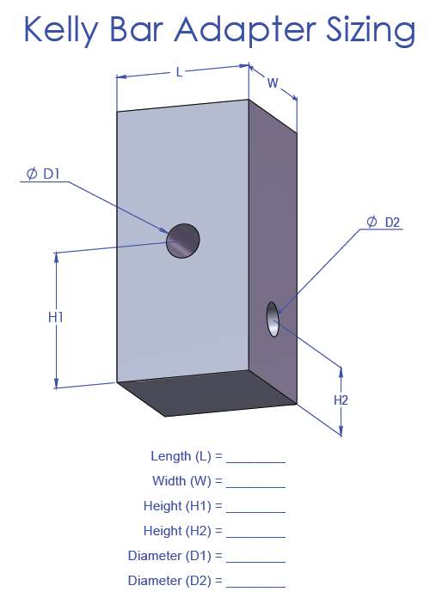

Figure 1. Kelly Bar Adapter Details

