SAMPLE SPECIFICATION for DRILLED SHAFT VERTICALITY AND SHAPE

In using this sample specification, it should be recognized that each site and structure is unique. Therefore, geotechnical judgment based upon knowledge of the local soil conditions and deep foundation installation practice should be used to modify this sample specification to address the specific requirements of a given project.

SECTION 1.0 – GENERAL

1.01 Summary of Work

The (Specialty Testing Consultant or the Contractor) shall perform drilled shaft verticality tests prior to concrete placement. The tests may be performed by the Specialty Testing Consultant (if independent 3rd party tests are specified) or they may be self-performed by the Contractor. When testing is performed by the Specialty Testing Consultant, the Contractor shall assist and lower the SHAPE device into the shaft excavation. The tests to determine shaft verticality, in-situ radius, and shaft excavation volume shall be performed no later than ___ (generally 2 hours or less) prior to commencing the shaft concrete pour.

(Note: The time allotted between testing and concrete placement should be limited. Long times can allow side wall material to cave in after shaft verticality and shape determination. The specifying engineer shall consider the potential deterioration of the slurry, the potential degradation of the shaft excavation sidewalls, the time necessary to transition to concrete placement procedures, and the availability of timely concrete delivery in selecting the maximum allowable time between verticality and shaft shape determination and commencement of concrete placement.)

1.02 Personnel

The firm performing drilled shaft verticality and shape determinations shall submit the detailed testing procedures as well as the firm’s qualifications and experience in performing the tests. Personnel shall have a minimum of one year of experience with the proposed verticality and profiling equipment and shall have performed at least five similar deep foundation projects. Final verticality and shape determination reports, as described in Section 4.0, shall be prepared by a registered professional engineer licensed to practice in the project location.

1.03 Verticality and Profiling Equipment

A Shaft Area Profile Evaluator (SHAPE) shall be used to assess the drilled shaft verticality, shape, and volume. The device shall include the following components:

SHAPE Device. The SHAPE device shall have a cylindrical shaped body with a height of approximately 26 inches (660 mm), a diameter of approximately 10 inches (254 mm), and a weight of approximately 65 lbs (30 kg). The SHAPE device shall include eight ultrasonic transmitters and eight ultrasonic receivers for determination of the in-situ shaft radius, shaft verticality, and the volume of the shaft excavation. For device to tablet communication and data transfer, the device shall be equipped with an Ethernet communication cable or with WiFi or Bluetooth wireless communication.

Kelly Bar Adapter. The dimension of drill rig Kelly bars vary depending upon the manufacturer and require an adapter to attach to the SHAPE device. For each drilling rig on the project, the contractor shall submit a completed Figure 1 to the equipment supplier 2 weeks prior to installing the initial drilled shaft with that drill rig.

SHAPE Tablet. The SHAPE tablet shall have a sunlight readable display screen with a minimum screen resolution of 1024 x 768. The tablet shall provide numerical and graphical display of the shaft radius, verticality, and excavation volume as well as have a minimum of 60 GB of internal memory storage. The tablet shall also be capable of remote operation via a high-speed internet connection.

The SHAPE system is manufactured by Pile Dynamics, Inc., 30725 Aurora Road, Cleveland, OH 44139, USA. The manufacturer can be contacted at www.pile.com/pdi; email: info@pile.com; phone: +1 216-831-6131; fax +1 216-831-0916.

SECTION 2.0 - TEST PROCEDURE

2.01 General Procedures

The SHAPE device shall be pin-connected to the Kelly bar using a properly sized adapter provided by the SHAPE equipment supplier or contractor, or with a compatible winch deployment system. After the pin-connection and prior to positioning over the open excavation for testing, the verticality of the SHAPE Unit shall be checked and confirmed.

The SHAPE device shall be connected to the SHAPE tablet using an ethernet cable or wireless connection. Once the “ready” indicator is activated (usually a flashing blue LED light), the SHAPE device shall be disconnected from the tablet and a watertight cap shall be securely placed on the Ethernet connector. The SHAPE device shall then be centered over the shaft excavation and lowered down the drilled hole for verticality and drilled shaft shape determination. A SHAPE test run is defined as a full descending and ascending transit of the SHAPE device. The SHAPE test shall be performed at a descending and ascending rate of approximately one foot per second (300 mm/sec).

After the ascending transit and once at the surface, the SHAPE device shall be reconnected to the SHAPE tablet using an ethernet cable or wireless connection to transfer the SHAPE device collected data to the SHAPE tablet. At the end of each run, the data should be checked and saved prior to terminating the test.

Note: A typical SHAPE test is expected to take on the order of 10-15 minutes following adapter attachment to the Kelly bar.

2.02 Access

To facilitate the specified testing, the Contractor shall provide access to the shaft location and excavation in accordance with all pertinent safety requirements (OSHA, etc.) and applicable safety standards. The Contractor shall provide a work area surrounding the shaft that is free of debris and hazards. The Contractor shall provide assistance, equipment, or materials as required to perform the tests.

SECTION 3.0 – VERTICALITY AND SHAPE ACCEPTANCE CRITERIA

Note: Verticality and minimum diameter criteria are frequently specified on drilled shafts as part of the shaft acceptance criteria. This is only a portion of the overall shaft acceptance criteria which includes shaft location, reinforcing cage, and concrete quality considerations.

3.01 Verticality

The verticality of drilled shafts shall be within ___ (per FHWA guidelines generally 1.5% for shafts in soil and 2% for shafts in rock) percent of plumb. The verticality shall be measured from the top of the poured drilled shaft concrete elevation or mudline, whichever is lower.

Note: Some verticality specifications are more stringent than those referenced in the above FHWA guidelines contained in GEC-10 (2018).

3.02 Diameter

The diameter of the drilled shaft excavation shall not be less than the minimum shaft diameter shown on the plans.

3.03 Shaft Excavation Volume

The drilled shaft excavation volume shall be calculated from the shaft toe to the plan top of concrete elevation.

Note: The concrete volume may exceed the drilled shaft’s excavation volume due to the presence of soft soil layers along the shaft length, the use of telescoping casing, and other construction procedures.

SECTION 4.0 – REPORTING

SHAPE test results shall be reviewed by qualified personnel on-site or remotely connected to the SHAPE unit immediately after removing the SHAPE unit from the drilled shaft excavation. Within 1 hour of removing the SHAPE device from the excavation, a field report on the shaft verticality, in-situ radius, and excavation volume shall be submitted to the Engineer of Record for each tested drilled shaft. As a minimum, the field report shall include the shaft number, shaft location, the test date and time, reference elevation, a plot of the shaft volume vs depth, a description of any shaft wall encroachment, a description of any unusual shaft features (bulges), and whether the shaft vertically and diameter meet the specification requirements.

Once per ___ (week, month, or other specified duration), or upon completion of various project or testing phases, a formal report shall be prepared and submitted to the Engineer of Record summarizing the test results for all shafts in a given foundation unit or area. This report shall be submitted no later than ___ (five) working days after the completion of the reported phase of testing.

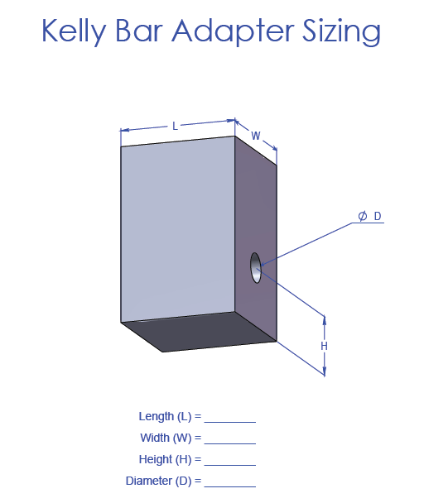

Figure 1. Kelly Bar Adapter Details

