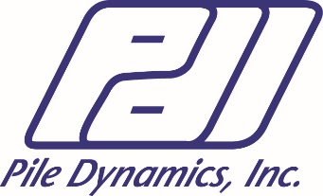
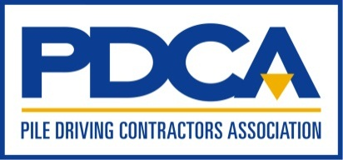

Pile Driving Contractors Association
and
Pile Dynamics, Inc.

Present

Seminar on Deep Foundation Integrity Testing and Wave Equation Analysis
September 11, 2019

High Strain Dynamic Foundation Testing Workshop & Proficiency Test
September 12 and 13, 2019

at the
PDI Headquarters
30725 Aurora Road
Cleveland, Ohio 44139
1-216-831-6131

Registration starts at 8:00am

Wednesday, September 11, 8:30am – 5:00pm

Seminar on Deep Foundation Integrity Testing and Wave Equation Analysis

Who should attend: Geotechnical, structural and construction engineers; owners, contractors and other professionals involved in the design, construction and specification of deep foundations.

- This seminar is suitable for those new to the field of Foundation Testing and Analysis, and includes an overview of non-destructive testing methods (integrity and load testing) and their applications.
- It is suitable also for those specifying the testing to gain basic understanding for assessing the results presented in reports.
- This seminar is suitable for those needing an understanding of wave equation analysis methods.
- Those attending the Workshop that follows this Seminar are strongly encouraged to attend this review of wave equation background materials.

Learning objectives: At the end of the seminar, attendees will be able to:

- Select an appropriate method of integrity assessment of deep foundations for a particular application.
- Review reports of integrity and dynamic load testing of deep foundations conducted by others.
- Run a basic wave equation analysis of pile driving.

Program (subject to change)

8:00 Registration
8:30 Wave Mechanics – Basics
9:30 Non-destructive testing – High and Low Strain
10:15 Break
10:30 Non-destructive testing – Crosshole Sonic Logging
11:00 Thermal Integrity Profiling
11:45 PDA Applications
12:15 Lunch
1:15 Wave Equation Background
2:15 Wave Equation Workshop: Bearing Graph, Insp. Chart
3:00 Break
3:15 Wave Equation Workshop: Bearing Graph, Insp. Chart-cont’d
3:45 Wave Equation Workshop: Driveability
5:00 Adjourn

Digital/ Hard copy of the Presentation:
- All training material will be available digitally for download prior to the event. It is suggested that attendees download this material to their laptop and bring their laptop, or print the training material and bring their own hard copy. A colored, 3 slide per page printout may be requested from PDCA up to two weeks prior to the seminar ($100 charge will apply). Please contact PDCA at kathy@piledrivers.org if you want PDCA to provide the hard copy.

GRLWEAP Demo License:
- Attendees are encouraged to use their own GRLWEAP USB key license. If you do not have a license or cannot bring the USB key license with you to follow along, a GRLWEAP 10 demo version will be offered and emailed the week before the Workshop.

Thursday, September 12, 8:30am – 5:00pm

High Strain Dynamic Foundation Testing Workshop & Proficiency Test Part 1

Who should attend:

- Users of the Pile Driving Analyzer® (PDA) system and CAPWAP® software interested in sharpening their skills.
- Engineers, foundation testing professionals, students and professors already familiar with the basic concepts of deep foundation dynamic testing and analysis.
- Professionals who desire to have a basic understanding of the dynamic test results being presented to them.
- Those interested in taking the Dynamic Measurement and Analysis Proficiency Test*

Learning objectives: At the end of this two-day workshop attendees will be able to:

- Operate the PDA in a manner conducive to acquiring good quality data
- Assess pile bearing capacity, pile driving stresses, hammer performance and pile integrity by various methods
- Avoid pitfalls when analyzing PDA data with the CAPWAP software
- Interpret PDA testing and CAPWAP software results
- Describe the soil-model used in CAPWAP
- Prepare the input for CAPWAP
- Review options for CAPWAP analysis and output
- Calculate bearing capacity and its distribution for driven piles from impact records

Program (subject to change)

8:30 Wave Mechanics for PDA testers (90 min)
10:00 Break
10:15 PDA Testing – Proper Practices
12:30 Lunch
1:15 Dynamic Testing of Drilled Shafts and Augered Piles
1:30 Testing Economics
3:15 Break
3:30 Set-up (Capital Gain with Time)
4:15 PDA Workshop: Integrity, Stresses, Energy
5:00 Adjourn

Friday, September 13, 8:30am – 5:00pm

High Strain Dynamic Foundation Testing Workshop & Proficiency Test Part 2

Program (subject to change)

8:30 PDA Workshop: Capacity Calculation
9:15 CAPWAP Background
10:45 Break
11:00 CAPWAP Examples
12:30 Lunch
1:15 CAPWAP and Refined Wave Equation
1:45 iCAP® – Instant Signal Matching
2:15 PDA Data Quality – Examples
3:15 Break
3:30 Dynamic Measurement and Analysis Proficiency Test *
5:00 Adjourn

Digital/ Hard copy of the Presentation:
- All training material will be available digitally for download prior to the event. It is suggested that attendees download this material to their laptop and bring their laptop, or print the training material and bring their own hard copy. A colored, 3 slide per page printout may be requested from PDCA up to two weeks prior to the seminar ($100 charge will apply). Please contact PDCA at kathy@piledrivers.org if you want PDCA to provide the hard copy.

GRLWEAP Demo License:
- Attendees are encouraged to use their own GRLWEAP USB key license. If you do not have a license or cannot bring the USB key license with you to follow along, a GRLWEAP 10 demo version will be offered and emailed the week before the Workshop.

Certificate of Completion:
- A Certificate of Completion documenting the number of hours of instruction – Professional Development Hours (PDH’s) will be provided. Check with your engineering board of registration for their continuing education requirements.
Dynamic Measurement and Analysis Proficiency Test:
- At the end of the High Strain Dynamic Testing Workshop participants may take a multiple-choice Dynamic Measurement and Analysis Proficiency Test which will take less than 1-½ hours to complete. The test will cover the theory of Wave Mechanics, Case Method (PDA) equations, data quality assessment, data interpretation and basic CAPWAP analysis. The test is designed for those with experience in using the Pile Driving Analyzer® system and CAPWAP to perform High Strain Dynamic Foundation Tests. The best preparation for the test is work experience following an initial PDA training. The workshop will refresh the participant’s theoretical background and be a reminder of some important points. Those taking the test are advised to study “Appendix A” and “Helpful Hints” of the PDA manual, review some of the EXAMPLE data provided with the PDA and read the CAPWAP background material. These materials are supplied with PDA purchases. Those without access to the manuals and examples should please contact softwaresales@pile.com in advance of the test date. For more information about the Proficiency Test website: www.PDAProficiencyTest.com.

- A Certificate of Proficiency in High Strain Dynamic Pile Testing will be awarded to those who pass the test. The Level indicated on the Certificate is dependent on the score achieved on the test. Those who do not pass the test will receive full credit of test registration fee to be applied towards retaking the test at the next opportunity.
*Please note it will take up to two weeks to receive your exam results*

Workshop and Seminar Lecturers

Frank Rausche, Ph.D., P.E., D.GE, is a principal of Pile Dynamics, Inc. (PDI) and of GRL Engineers, Inc. (GRL). He has been involved in the research and development of dynamic testing and analysis methods since his mid-1960s work at Case Western Reserve University, where he derived the Case Method equations for dynamic pile testing and developed the CAPWAP and GRLWEAP software. Dr. Rausche has been a consultant throughout his career applying the dynamic and testing methods to solve practical problems on construction sites. He has published numerous papers and lectures frequently both in the USA and internationally.

Garland Likins, P.E., M.ASCE, is the senior partner and past president of Pile Dynamics, Inc., a manufacturer of quality assurance products for deep foundations. He is a licensed Professional Engineer in Ohio and a former principal of GRL Engineers, Inc., providers of deep foundation testing services. In his 45 years since participating in the original dynamic pile testing research at Case Western Reserve University, Garland has performed countless field tests and directed the development of several field testing devices for deep foundations. He is active in committees for ASTM, ADSC, DFI, and PDCA. He authored numerous publications and frequently lectures on deep foundations.

Brent Robinson, Ph.D., P.E., is a partner in PDI and GRL. He oversees civil engineering and research and development activities and trains users of PDI equipment. Since joining GRL in 1999, he has performed measurement and analysis for foundation projects around the world. Brent is a frequent lecturer, chair of the Geotechnical Committee of the Cleveland Section of the American Society of Civil Engineers, a member of standing committees of the Transportation Research Board, and the recipient of the TRB Best Paper Award in Soil Mechanics in 2010.

Ryan Allin, P.E., is a senior engineer and partner in GRL Engineers and Pile Dynamics. He has a B.S. in Civil Engineering from Cleveland State University and has achieved Expert level on the PDCA/PDI Dynamic Measurement and Analysis Proficiency Test. After several years performing the entire range of services offered by GRL throughout the United States and in international offshore projects, Ryan is currently responsible for all GRL’s educational programs for foundation testing professionals. In that capacity he has lectured on numerous seminars, webinars and workshops on foundation testing and has co-authored papers on the subject. Ryan is a member of the American Society of Civil Engineers and a registered professional engineer in Ohio, Pennsylvania, West Virginia, Delaware and Kentucky.

Hotel Reservations – INFORMATION ON LAST PAGE

Attendees should make their own hotel reservations.

REGISTRATION

Online Registration: www.piledrivers.org

Early Bird Deadline: Friday, August 9, 2019

Mail, Fax, or Email: Registration form by Friday, August 23, 2019 to:

Pile Driving Contractors Association
33 Knight Boxx Road, Suite 1, Orange Park, FL 32065
Phone: 904-215-4771; Fax: 904-215-2977
kathy@piledrivers.org

Name(s): ____________________________________________________________________

Organization:

Address:

City:_____________ State/Province:_____________ Postal Code: ______ Country:

Phone: ___________________ Fax: ____________________ Email:

REGISTRATION FEES (Includes: AM/PM Breaks and Lunch):

□ Seminar on Deep Foundation Integrity Testing and Wave Equation Analysis: $300.00

□ High Strain Dynamic Foundation Testing Workshop: $550.00

□ Dynamic Measurement and Analysis Proficiency Test (No Discounts): $200.00
*If you do not pass the test you are allowed one (1) retake of the test at no additional charge at the next course

□ Early Bird Registration: $50 discount on each Seminar and Workshop by August 9, 2019

□ Government Employees: $50.00 discount on each Seminar and Workshop

Amount sub-total: $____________

Discount (if applicable – subtract): $____________

Grand Total: $____________

CREDIT CARD INFORMATION:

I am paying by: ___ VISA ___ MasterCard ___American Express ____ Check

Name (as on credit card):

Account Number:_________________________________ Expiration date: ___/ ___Verification code: _____

Statement Billing Address:

City:_________________ State / Province: _________________ Zip:__ _________Country:___________

Signature______________________________________________________

Refund Policy: Cancellations received by August 23, 2019 will receive a 50% refund. After this date, there will be no refunds, however name changes are permissible. There will be no transfer of funds to the next course permitted.

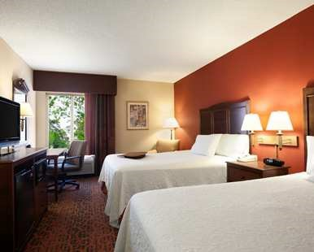

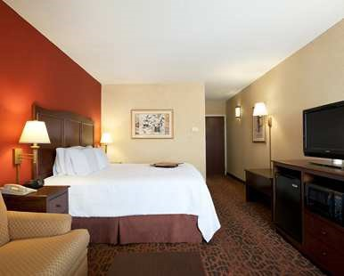

work • play • relax

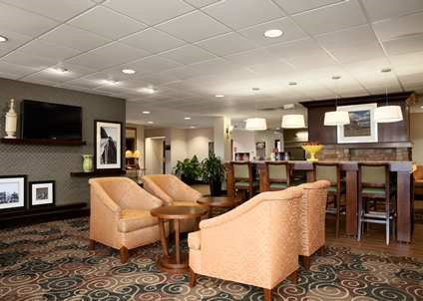

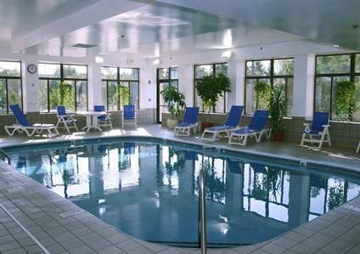

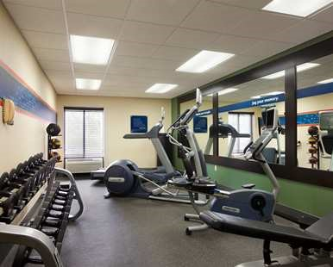

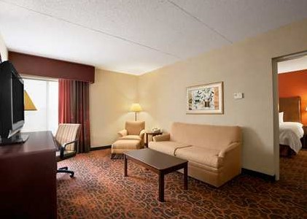

Hampton Inn Cleveland / Solon

Pile Dynamics Inc. September Workshop

Real value from your friends at Hampton!
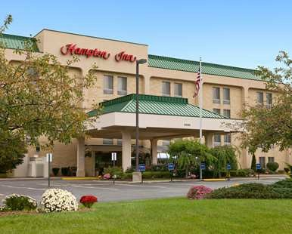

• Pay for breakfast? Not on our watch! Enjoy our complimentary On the House® hot breakfast buffet or our On the Run® to-go bags daily from 6:00 AM to 10:00 AM.
• Relax and unwind after a long day during our Hampton Connect Reception featuring beverages and light snacks on Wednesday evening from 530 to 6:30 PM.
• Keep up your healthy routine by enjoying our Jump-Start® fitness center featuring
Precor® equipment followed up by a refreshing plunge into our indoor heated pool.
• Have a last minute report? No worries - we got you covered. Our 24-hour business center features high-speed internet access, printer, copier and office supplies.
• Our Suite Shop® offers a variety of food and convenience items for those times when you forgot to pack an essential, or just have the munchies late at night.

1 King Bed Room 2 Double Beds Room
Group Rate
$124
Per night plus tax

Online Reservations

Simply Click Here

Each guest room is well appointed with...

• Mini refrigerator, microwave, coffee maker with ample room to spread out and relax
• Complimentary high-speed, wireless Internet access with 24-hour technical support
• Deluxe 32” LCD screen television with over seventy cable channels including HBO
• Two line telephones with fully customizable voice mail and free local calls
• Custom-designed alarm clock with MP3 player and pre-set ambiance channels
• Spacious work desk with easy to access electrical connections for all your devices
Or use Group ID “PDI” at clevelandsolon.hamptoninn.com

Telephone Reservations

1-800-HAMPTON Request your preferred rate using Group ID “PDI”

we love having you here!

6035 Enterprise Parkway Solon, OH 44139
Clevelandsolon.hamptoninn.com
440-542-0400 tel
440-542-0353 fax
@hilton.com

